# CS 255 System Design Document Template

## UML Diagrams

Joseph Farrish

[Joseph.farris@snhu.edu](mailto:Joseph.farris@snhu.edu)

### UML Use Case Diagram

### UML Activity Diagrams

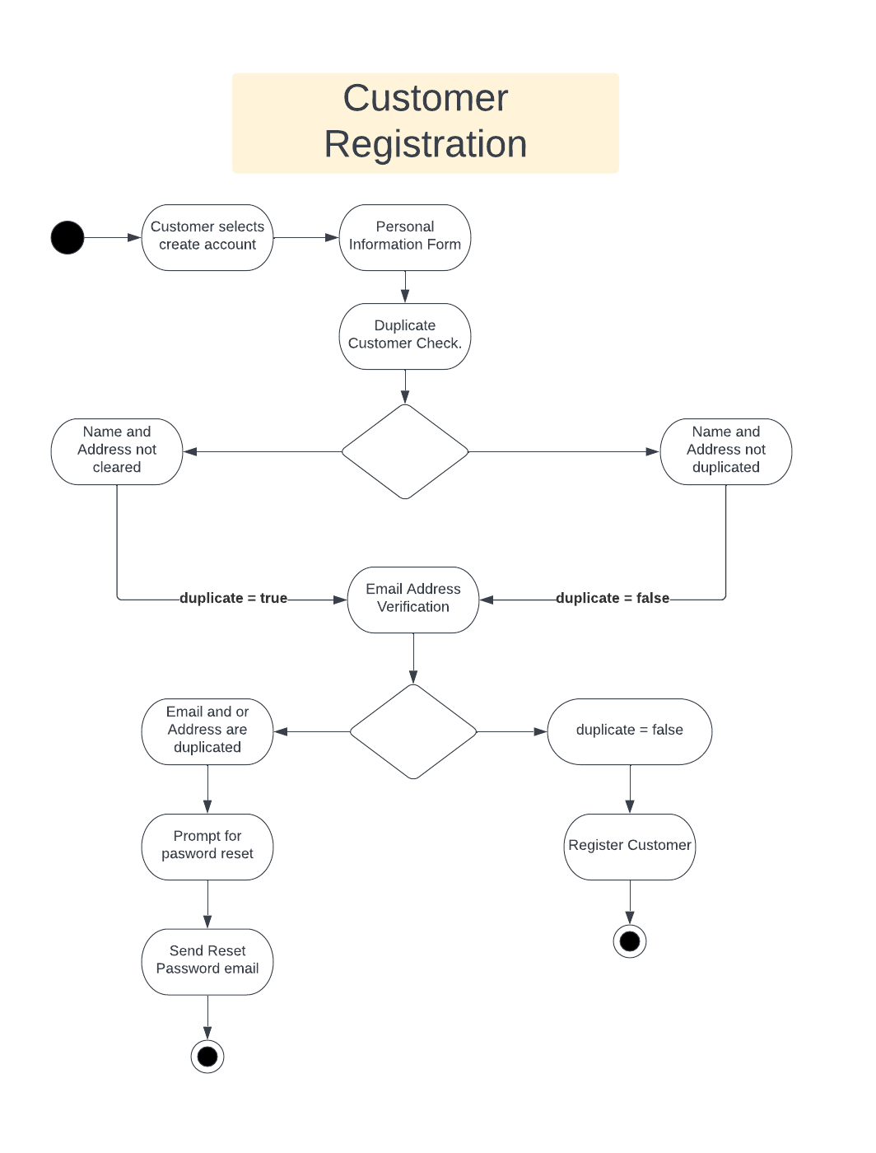

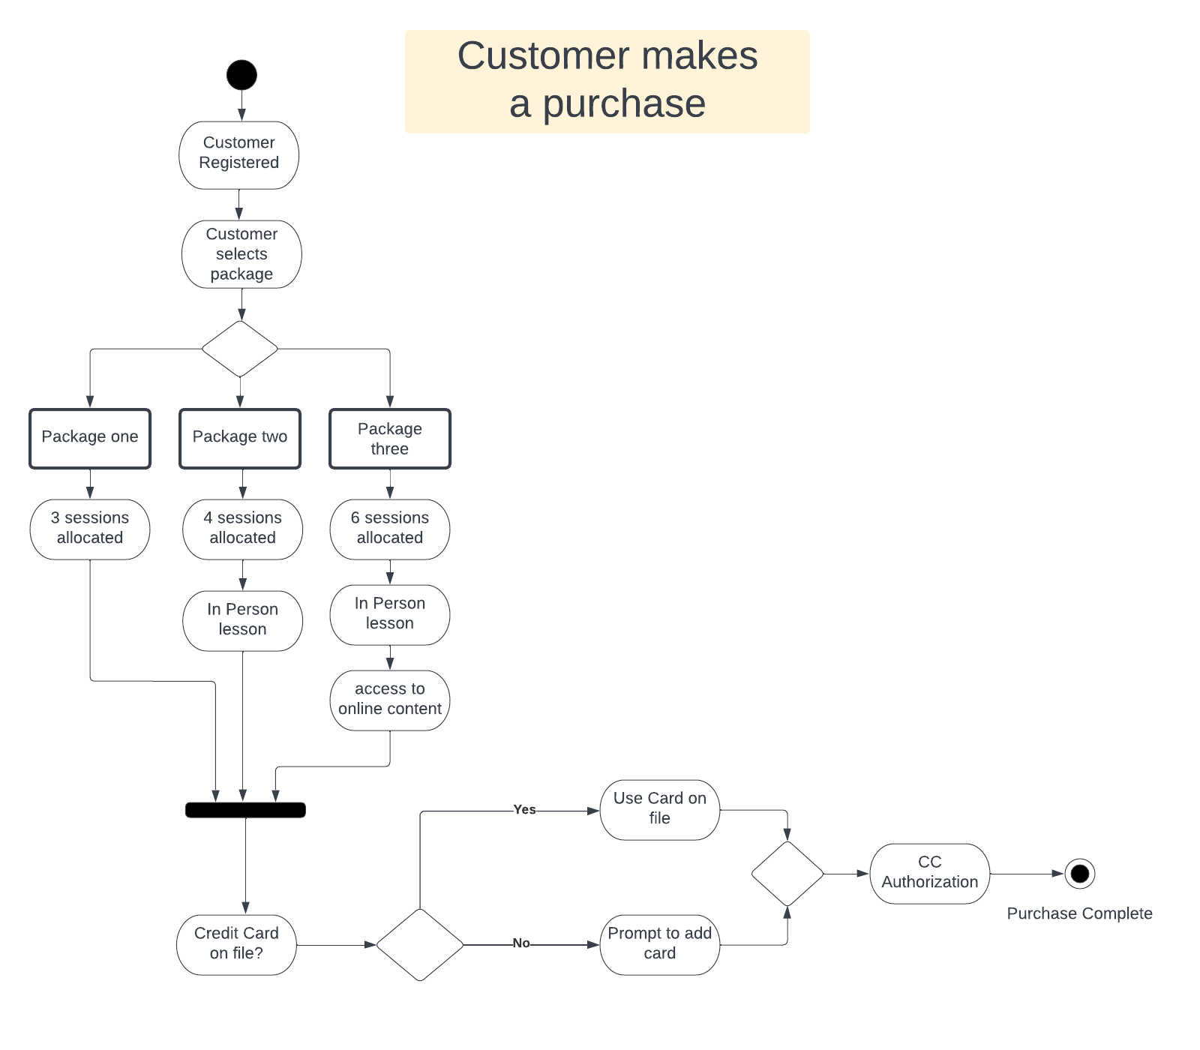

### UML Sequence Diagram

### UML Class Diagram

## Technical Requirements

**Overview.**

The nature of the proposed system described by the customer and the designs generated, warrant the use of cloud technology. Given the nature of a system that serves user data, administers tests, and schedules lessons use of tandem SQL and No-SQL database services are recommended. For storing the customer data structures a SQL database service is recommended. For scheduling a No-SQL service that utilizes JSON is recommended. For the front-end a WebApp service is recommended to deliver the front-end design presented by the customer. For logging the use of a cloud-based logging service is recommended. In Microsoft Azure this is referred to as blob storage. These types of services typically interface with a database system of choosing. Given the structure of logging events use of an additional database SQL schema is recommended for storing this data (Introduction to Azure Storage - Cloud Storage on Azure, 2022). A cloud-based system of services allows the customer to focus on the Driver Pass business without being too concerned with the technical aspects.

**Non-Functional Requirements.**

The DriverPass system shall contain the following behavioral properties that outline performance and usability that will be designed.

* Administrators should be able to access logging information, statistics, and Administration capability from any computer with a Browser. This data should be downloadable.
* Administrators require full access to over all accounts. This means they can reset, disable, or view activity from any computer via a login. Security of all users is a high priority.
* The system must support functionality required by Administrators, Employees, Teachers, and Students. Security discerns and levels are user dependent.
* The system needs to serve an appropriate front end to Admins, Employees, Teachers, and Students.
* The most important non-functional requirement is serving a suitable front end to the students vi a web browser. Performance of the front end is vital to attract and maintain the customer base. The front end needs to display the following information and perform the following functions required by the customer or end user.
* Display online tests and the current progress.
* Allow the students to take, pause and return to online tests.
* Allow the student to schedule lessons with a teacher.
* When a lesson is scheduled, the student shall see a picture of the teacher.
* Display comments left by a teacher as well as time information on previous lessons.

**Functional Requirements**

The Driver Pass system shall contain the following processes and information in its performance.

* All activity Employee, Teachers and Student activity should be logged.
* Customers will need to schedule Lessons with a teacher. The scheduling system needs to allocate these in two-hour blocks.
* Customers will need to make payments and payments will need to be processed on the system.
* Customer will be able to call in and speak to an employee and thus an employee will need to have the ability to register, schedule lessons and cancel this activity upon customer requests.
* Registration should contain the following customer information
  + Name
  + Address
  + Phone Number
  + Credit Card information
* Lessons should contain the following information.
  + Date and Time
  + Pickup and Dropoff locations.
  + Teacher info
* The system will need to serve online tests and lessons. This content shall be updateable via a pipeline from DMV.

**Recommendations**

As stated earlier a cloud-based solution is recommended for Driver Pass and while this could mean Microsoft Azure, Google Cloud, or Amazon Cloud. A significant amount of research has been developed based on the Learning Management System - LMS called Pupil First. This provides a lot of premade functionality for an online schooling system that would be of value in the development of DriverPass. Pupil first development is possible on macOS12, Ubuntu(22.04) and Windows 11 platforms. Pupil first has been thoroughly tested and designed with Heroku which provides platform as a service. Development of the front-end would be done using the popular React framework using ReScript library, Pupil First is a Ruby on Rails application using GraphQL API on the serve side(Pupilfirst LMS- Introduction for developers, n.d.). To assert the total recommendation: Build upon the Pupil first codebase using Web Apps and the Heroku platform. The cloud solution would ultimately depend on what Heroku uses under the required circumstances.

**References**

Craigshoemaker. (n.d.). *What is azure static web apps?* Microsoft Learn. Retrieved December 11, 2022, from https://learn.microsoft.com/en-us/azure/static-web-apps/overview

Introduction to Azure Storage - Cloud storage on Azure. (2022, October 12). Microsoft Learn. Retrieved October 15, 2022, from https://learn.microsoft.com/en-us/azure/storage/common/storage-introduction

Person. (n.d.). *Distributed data and compute, simplified.* Fauna. Retrieved December 11, 2022, from https://fauna.com/features#document-relational

*Pupilfirst LMS - Introduction for developers*. Pupilfirst LMS. (n.d.). Retrieved December 11, 2022, from https://docs.pupilfirst.com/developers/